**Assignment-1**

**Dept Table:**

|  |  |  |
| --- | --- | --- |
| **DeptNo** | **Dname** | **Loc** |
| 10 | Accounts | Bangalore |
| 20 | IT | Delhi |
| 30 | Production | Chennai |
| 40 | Sales | Hyd |
| 50 | Admn | London |

**Emp Table:**

|  |  |  |  |  |  |  |
| --- | --- | --- | --- | --- | --- | --- |
| **EmpNo** | **Ename** | **Sal** | **Hire_Date** | **Commission** | **DeptNo** | **Mgr** |
| 1001 | Sachin | 19000 | 1-Jan-1980 | 2100 | 20 | 1003 |
| 1002 | Kapil | 15000 | 1-Jan-1970 | 2300 | 10 | 1003 |
| 1003 | Stefen | 12000 | 1-Jan-1990 | 500 | 20 | 1007 |
| 1004 | Williams | 9000 | 1-Jan-2001 | NULL | 30 | 1007 |
| 1005 | John | 5000 | 1-Jan-2005 | NULL | 30 | 1006 |
| 1006 | Dravid | 19000 | 1-Jan-1985 | 2400 | 10 | 1007 |
| 1007 | Martin | 21000 | 1-Jan-2000 | 1040 | NULL | NULL |

1. Select employee details  of dept number 10 or 30

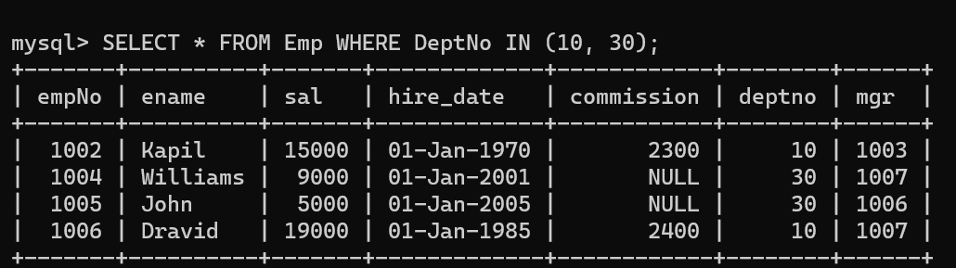

1. Write a query to fetch all the dept details with more than 1 Employee.

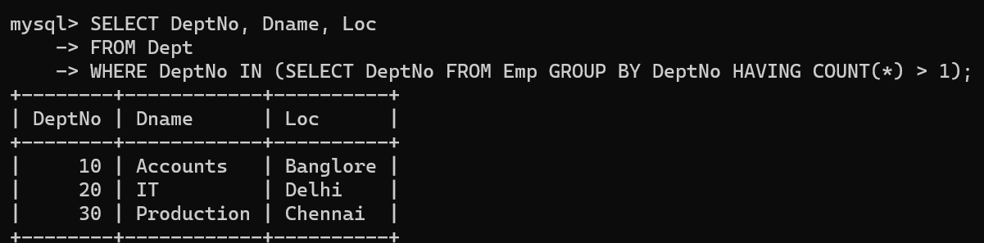

1. Write a query to fetch employee details whose name starts with the letter “**S”**

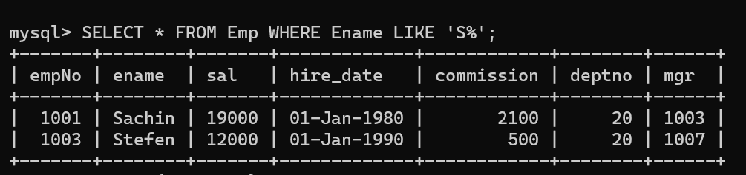

1. Select Emp Details Whose experience is more than 2 years

1. Write a SELECT statement to replace the char “a” with “#” in Employee Name ( Ex:  **Sachin** as **S#chin)**

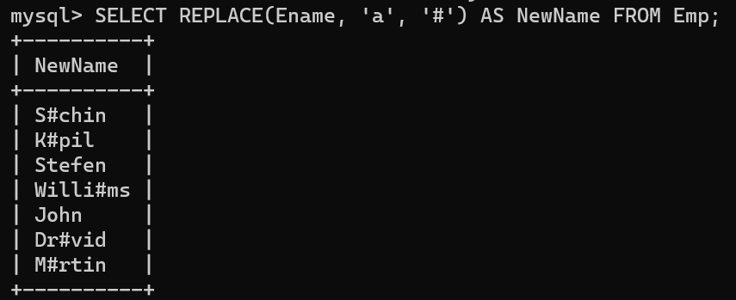

1. Write a query to fetch employee name and his/her manager name.

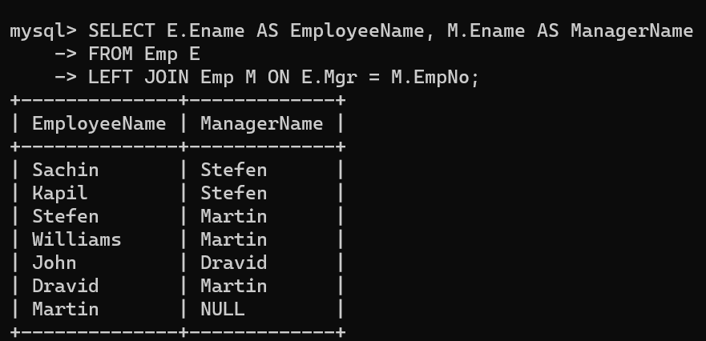

1. Fetch Dept Name , Total Salary of the Dept

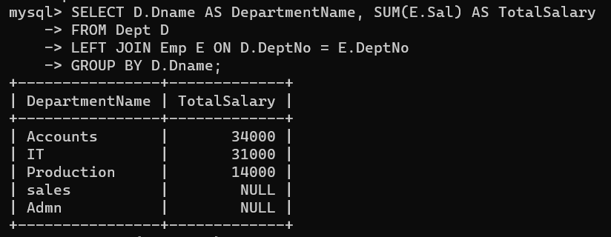

1. Write a query to fetch **ALL** the  employee details along with department name, department location, irrespective of employee existence in the department.

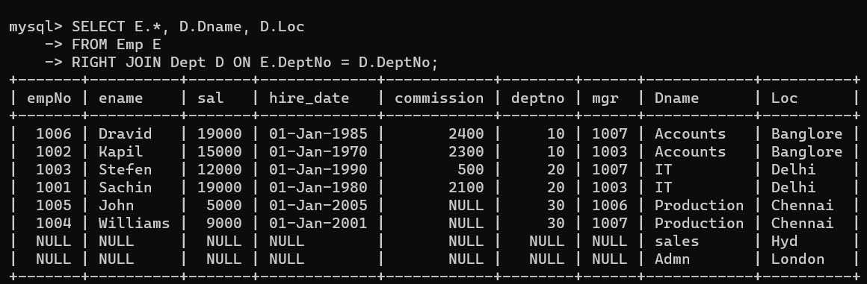

1. Write an update statement to increase the employee salary by 10 %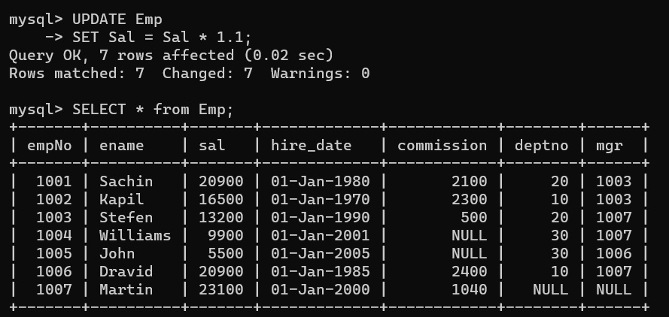
2. Write a statement to delete employees belonging to Chennai location.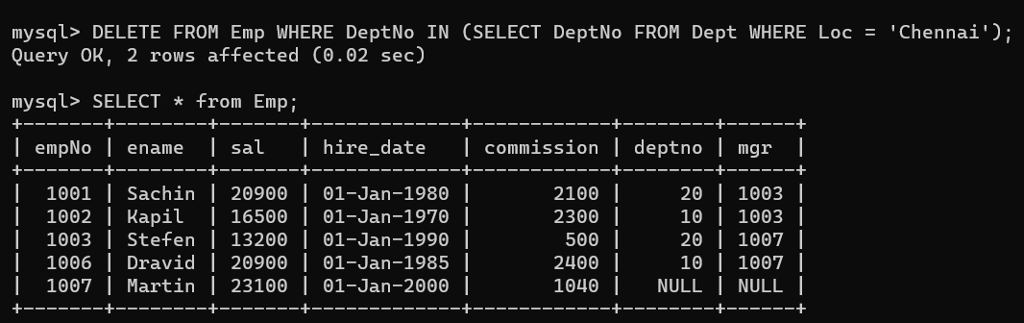
3. Get Employee Name and gross salary (sal + commission) .

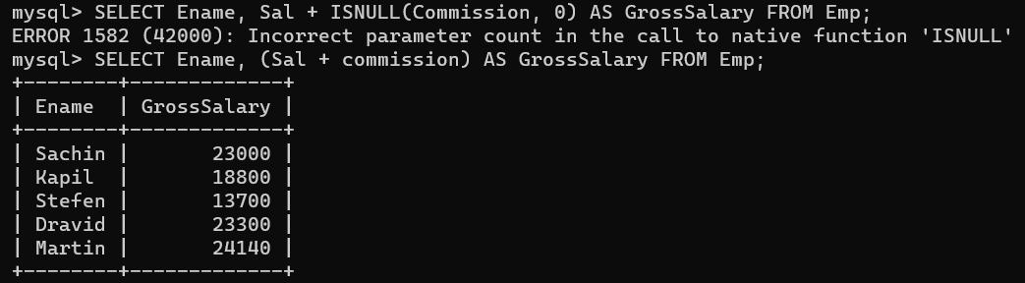

1. Increase the data length of the column Ename of Emp table from  100 to 250 using ALTER statement

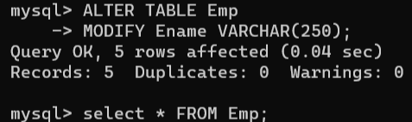

1. Write query to get current datetime

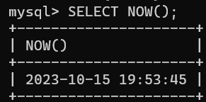

1. Write a statement to create STUDENT table, with related 5 columns

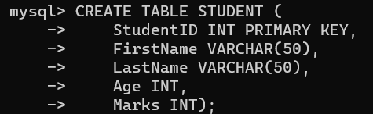

1. Write a query to fetch number of employees in who is getting salary more than 10000

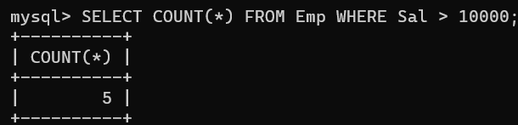

1. Write a query to fetch minimum salary, maximum salary and average salary from emp table.

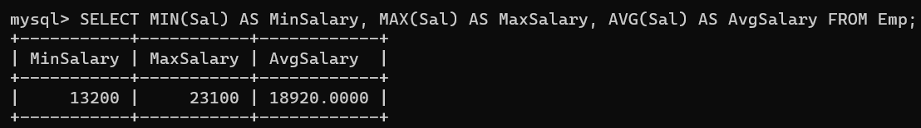

1. Write a query to fetch number of employees in each location

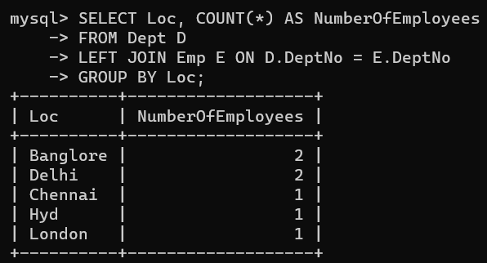

1. Write a query to display employee names in descending order

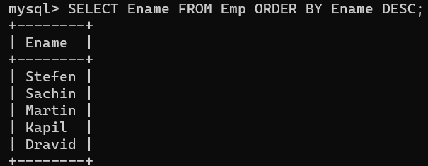

1. Write a statement to create a new table(**EMP_BKP**) from the existing **EMP** table

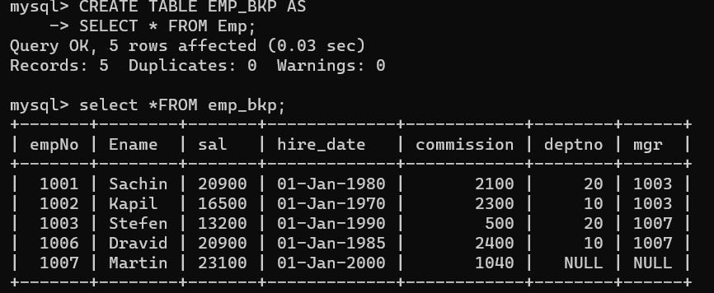

1. Write a query to fetch first 3 characters from employee name appended with salary.

21) Get the details of the employees whose name starts with **S**

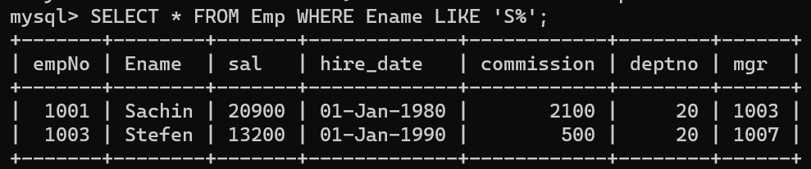

22) Get the details of the employees who works in Bangalore location

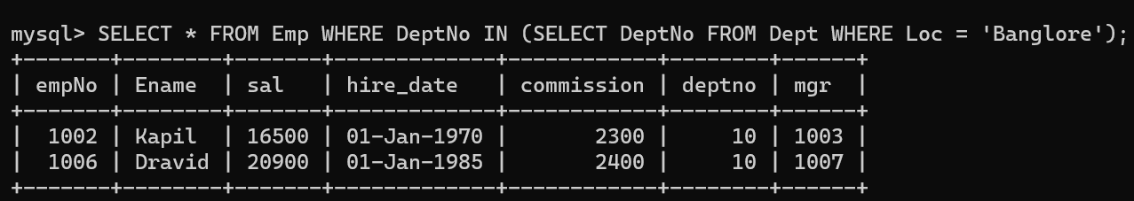

23) Write the query to get the employee details whose name started within  any letter between  A and K

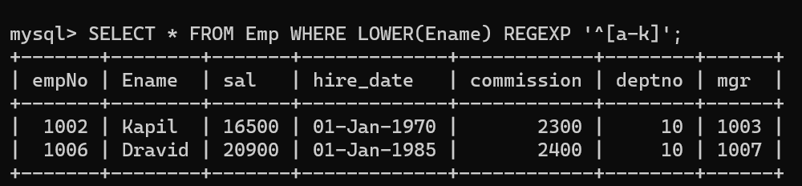

24) Write a query in SQL to display the employees whose manager name is **Stefen**

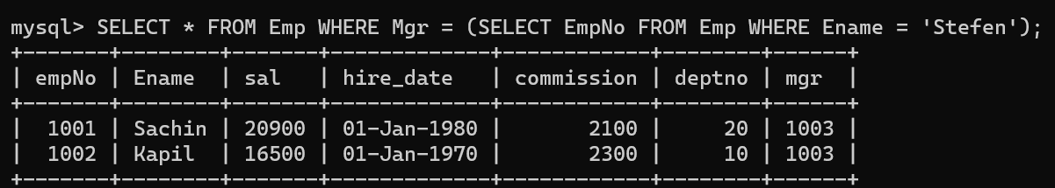

25) Write a query in SQL to list the name of the managers who is having maximum number of employees working under him

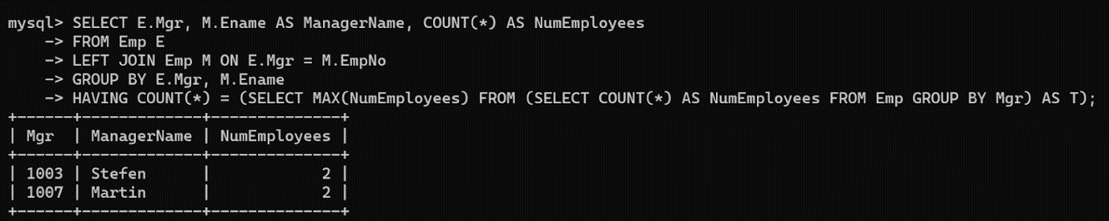

26) Write a query to display the employee details, department details and the manager details of the employee who has second highest salary

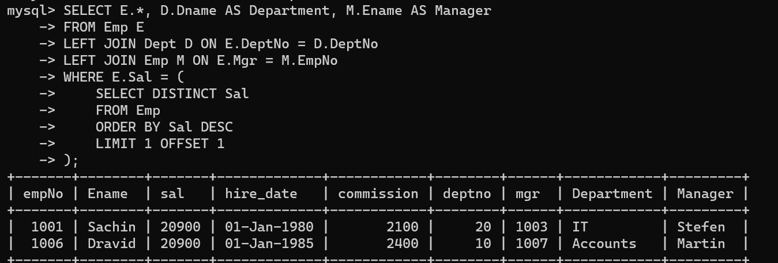

27)Write a query to list all details of all the managers

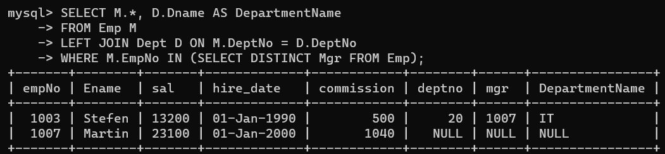

28) Write a query to list the details and total experience of all the managers

29) Write a query to list the employees who is manager and takes commission less than 1000 and works in Delhi

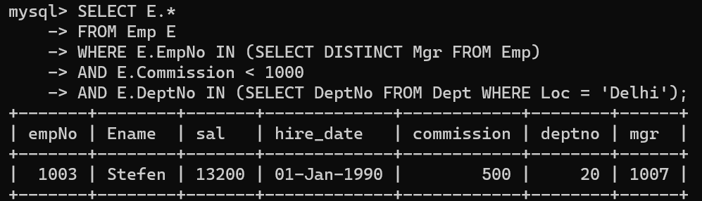30) Write a query to display the details of employees who are senior to Martin

